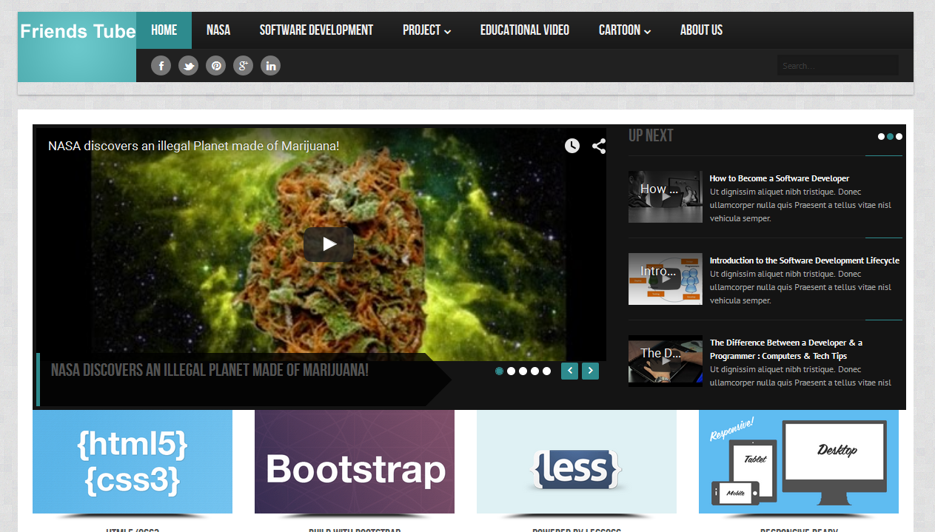
How to made friends tube
Log in admin panel of LaraCMS which is a CMS created through Laravel framework.
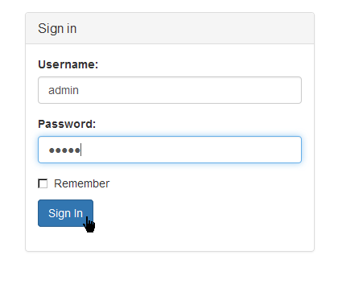
We made a layout for our friends’ tube.
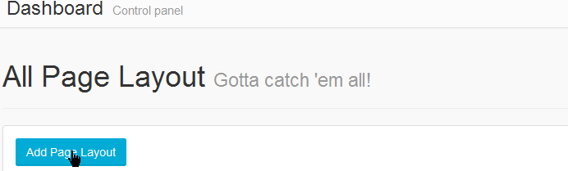

We did form fill-up in layout page.
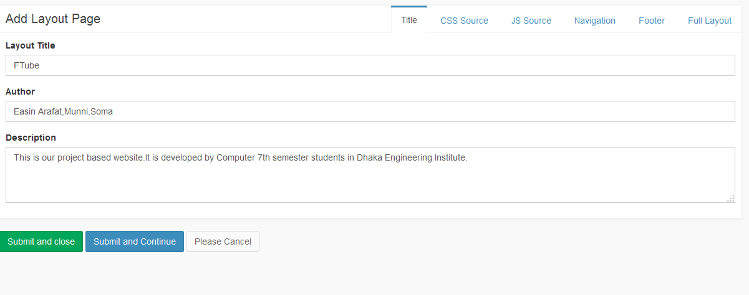
We add CSS style sheet source with our layout
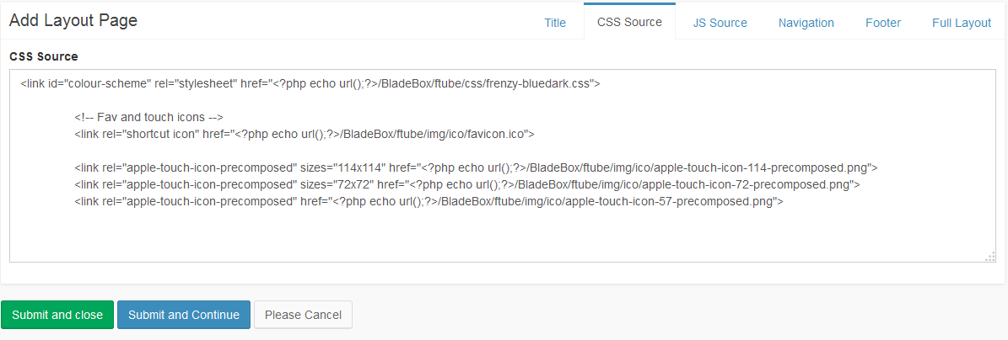
We add JS style sheet source with our layout
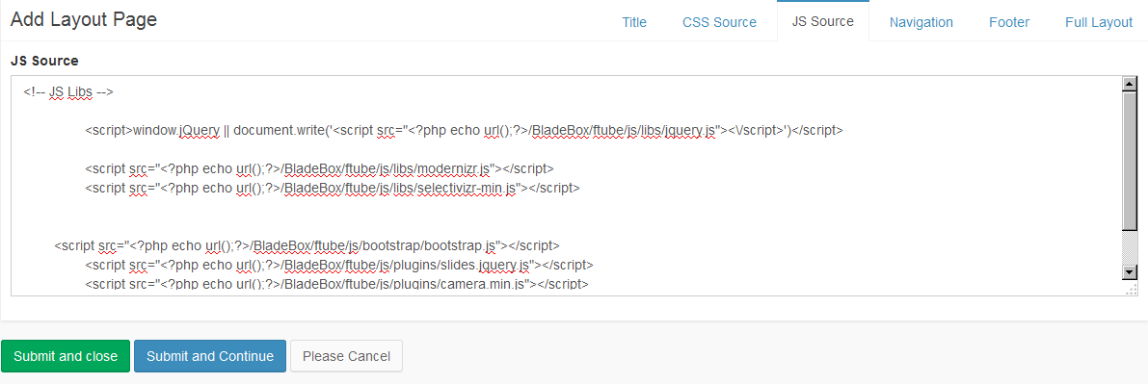

Then, we made navigation system on our website.
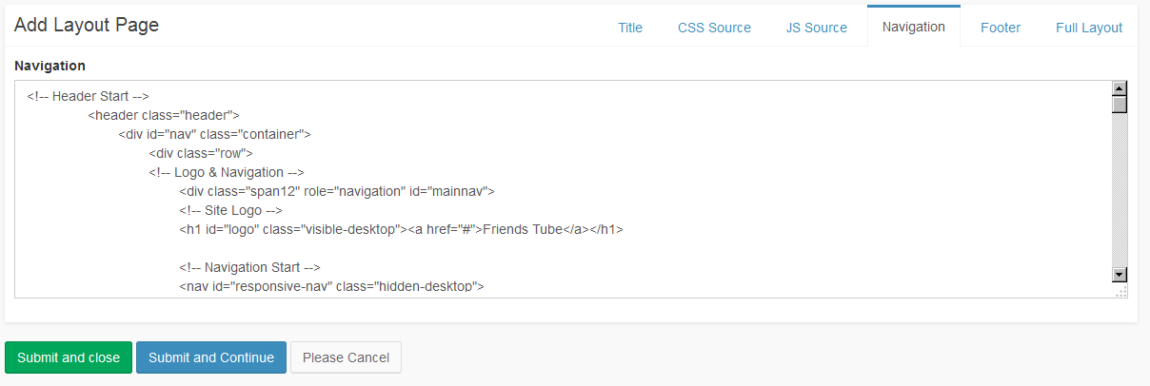
We add our footer page.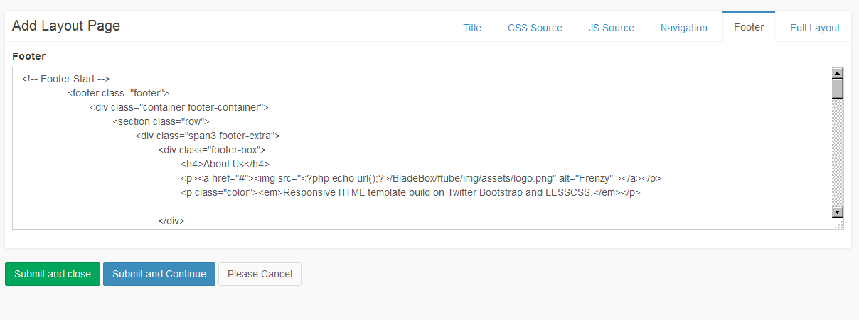Finally, we made full layout and did finish our layout.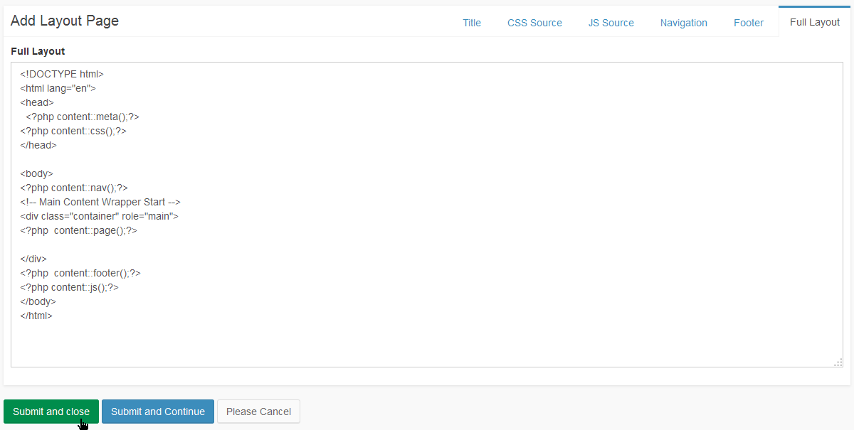
We had to create page for our website.
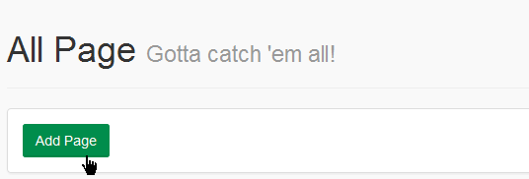
We made our home page adding title, meta data of the page.
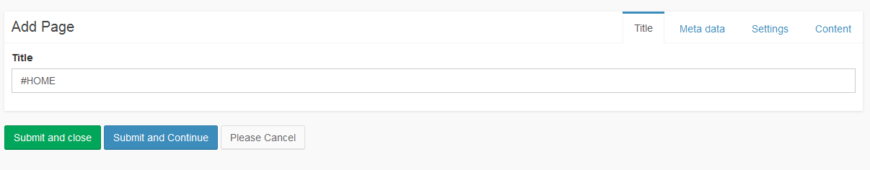
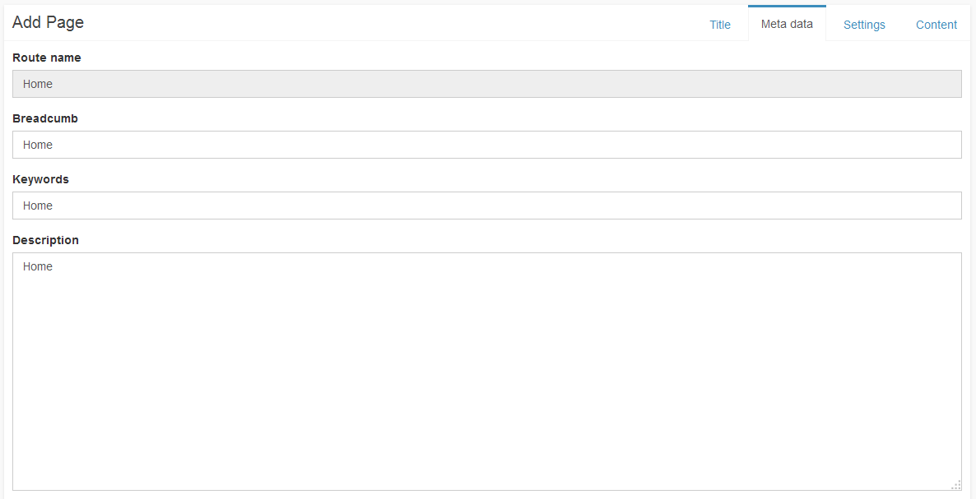
We had to set our page layout which we made.
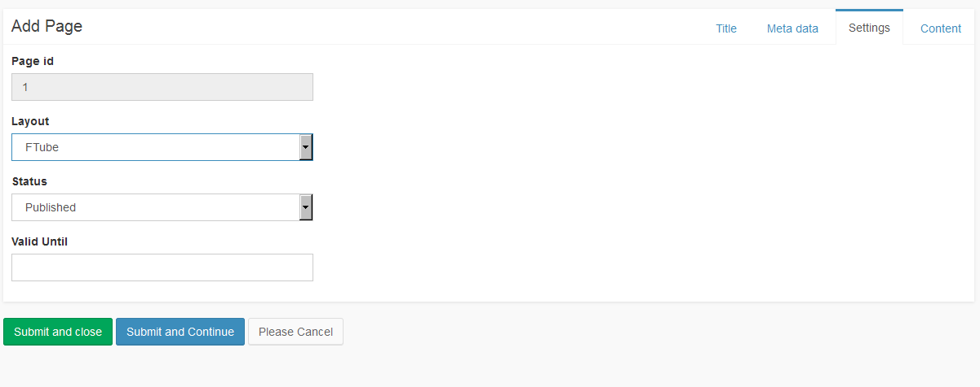

Then, we made our content of the home page.
